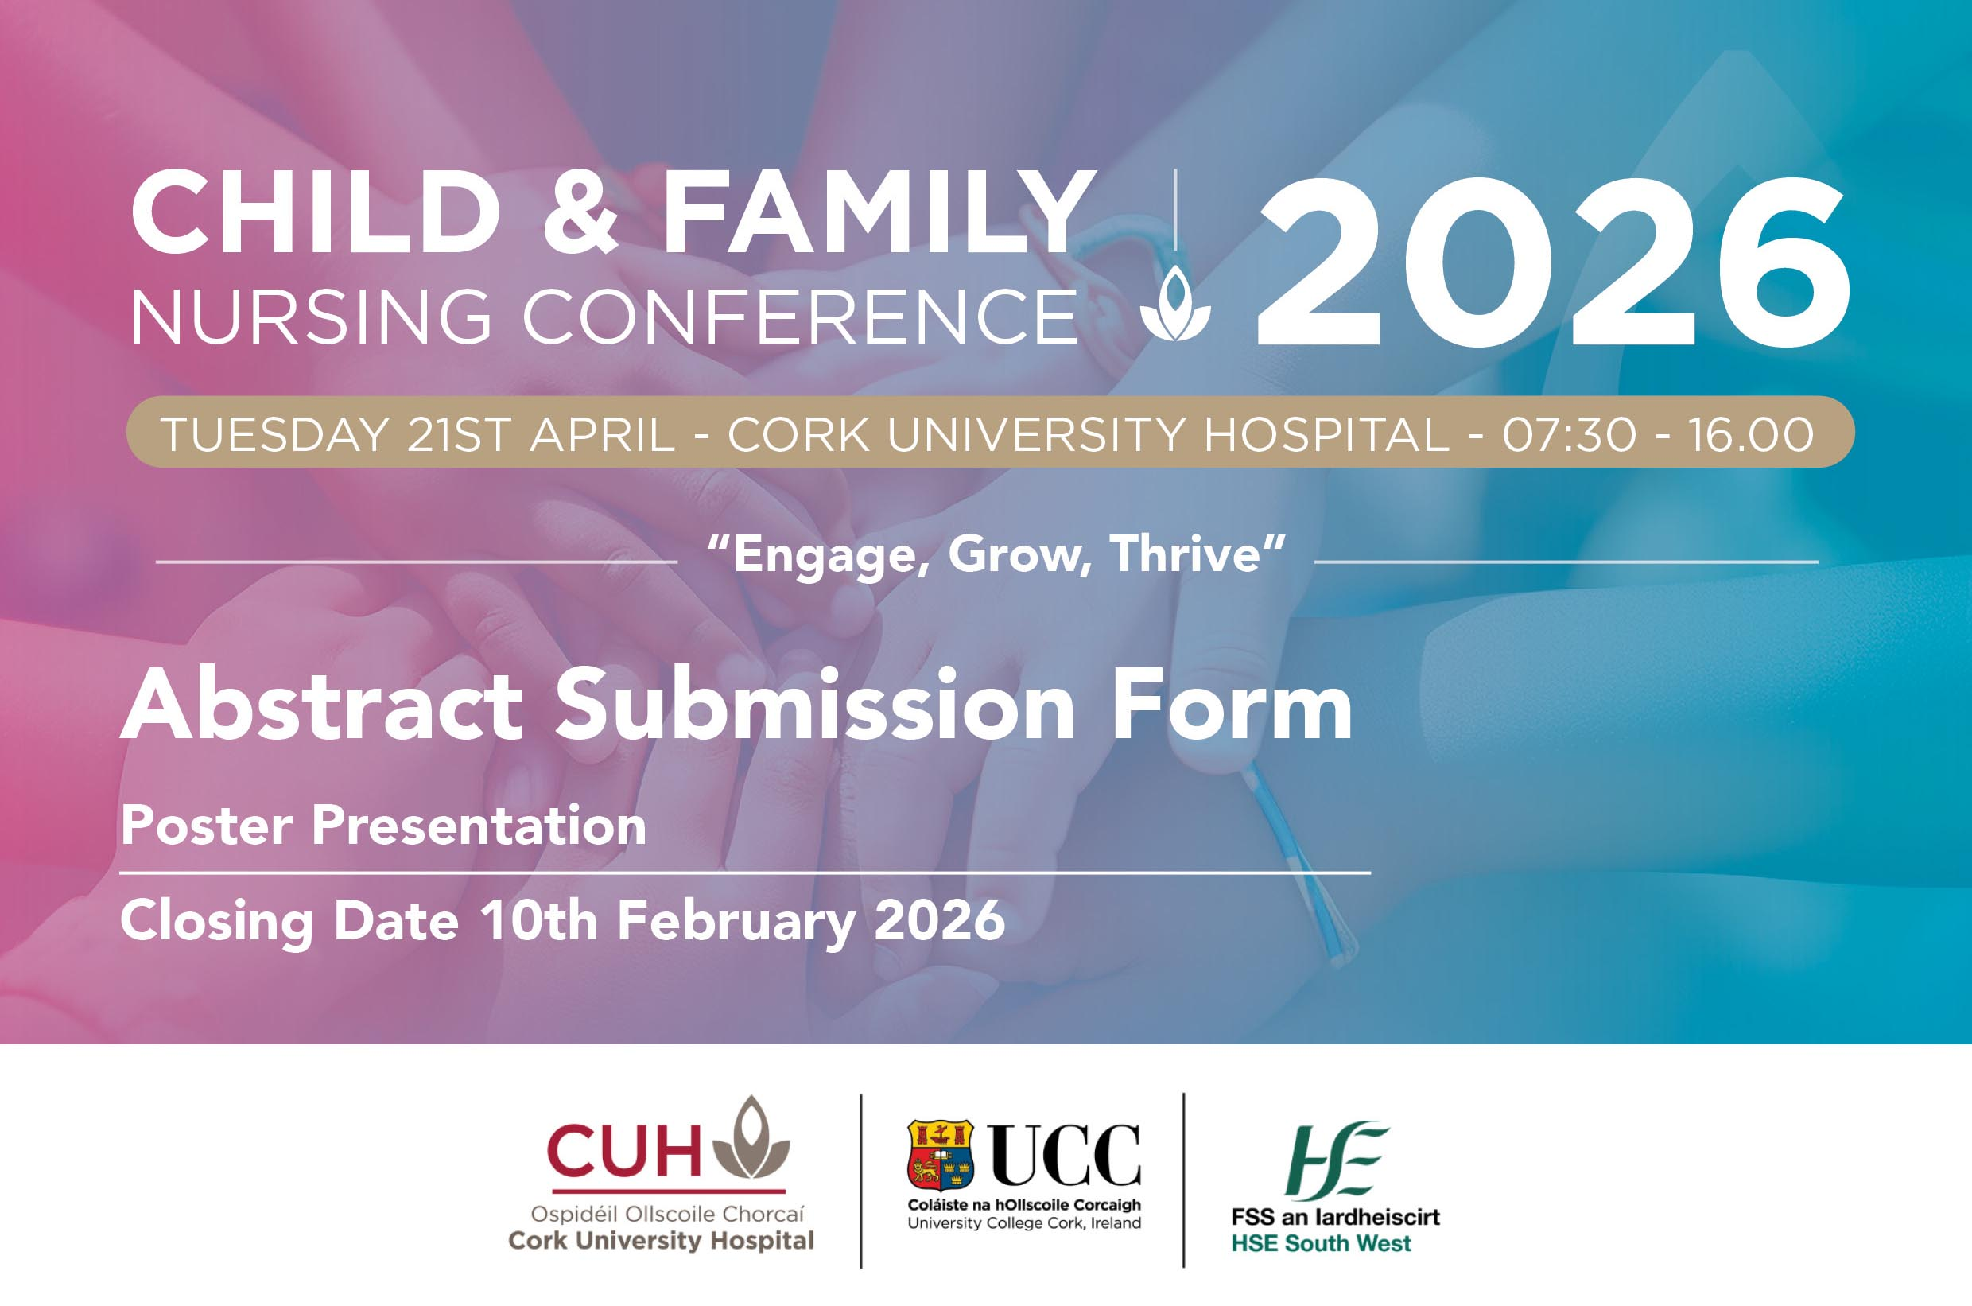

CUH Annual Child & Family Conference,

Tuesday 21st April 2026

All submissions must be typed clearly. Please avoid diagrams, illustrations, tables, references or graphics in the abstract. The presentation title should not exceed 25 words and body of text for the submission should not exceed 250 words, excluding title, author and references.

Email completed form to Clare and Emily at clare.obrien4@hse.ie and
emily.hallissey@hse.ie - Closing Date 10th February 2026

Please ensure all co-authors are aware of the contents of the abstract before submission.

Presenter (s) Name (s): | Organisation/Setting:
Contact Email: Contact Telephone:

Presentation Title:

Background (brief reason/description of the project/research):

Objectives:

Process/Methods /Model of care (as applicable):

Outcomes (Please provide data/results where applicable):

